Configuring Kali Linux
- Kali Linux will be used as an attack machine to transmit different forms of offensive actions against my Domain Controller and the other machines attached to it.
- I’ll also use Kali Linux to configure the pfsense firewall. This will make it easier to test out different offensive attacks without having to switch machines.
- When setting up Kali Linux make sure to allocate at least 80GB of disk space, 4GB of memory, 4 processors, and add an additional network adapter and set it to Vmnet1.
- If you remember in pfsense Vmnet1 is our LAN

pfsense Interfaces and Rules
- Once Kali is configured and booted up navigate to the web-browser and search for 192.168.1.1
- select “Advanced” and select “Accept”
- Once you see the pfsense portal login with the default credentials “admin” and “pfsense”
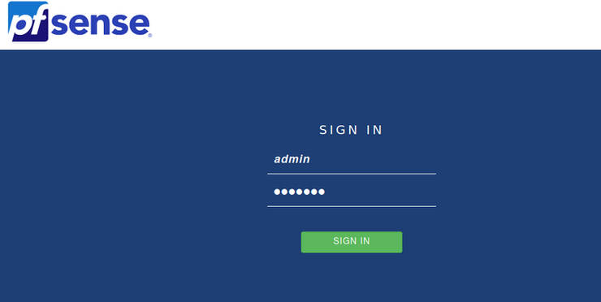
- Now we will begin setting up our pfsense configurations
- begin with adding 8.8.8.8 as the primary DNS Server. Then 4.4.4.4 as our secondary
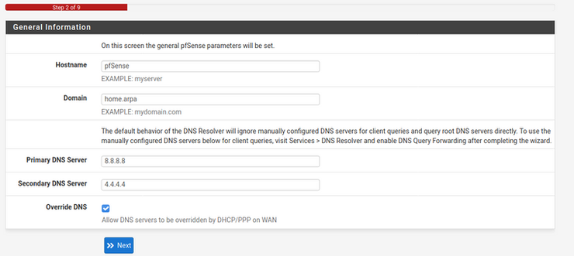
- Choose the timezone
- Keep clicking “Next” until prompted to set a new admin password.
- Setup a new password and click finish!
- Now its time to make changes to our interfaces.
- Click Interfaces → Start with LAN
- Change the description to KALI and set IPv6 to “None”
- Now we will update the rest of the Interfaces to the following:
- OPT1 → VictimNetwork
- OPT2 → SecOnion
- OPT3 → SpanPort (In pfsense we did not assign an IP address, but we did create an interface. Also make sure to enable it in the interface configuration)
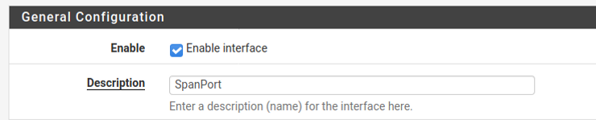
- OPT4 → Splunk
- Now we will create a Bridge using VICTIMNETWORK
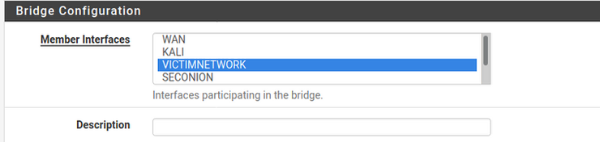
- Under Advanced Configuration for Span Port make sure to select SPANPORT
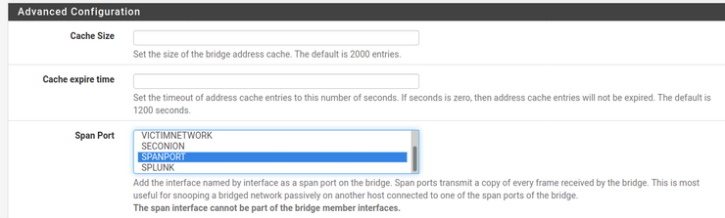
- Click save
- Now I’m going to add a new firewall rule that will allow any protocol. Normally this is not recommended, but for the lab’s sake its ok!
- Select Firewall → Rules → Add
- Under Protocol select ANY
- Save

That concludes my firewall configuration. This setup helped me understand the basics of setting up a firewall, but also should show some interesting alerts in the SIEM and ultimately have a better understanding of being a SOC Analyst.

